Lang Chen

PUBAFF149

2021/02/07

Lang Chen

PUBAFF 120

2021/11/21

**City-wide Earned Income Tax Credit in Los Angeles**

Poverty has always been a problem in California, especially Los Angeles, where poverty concentrates in the urban areas. According to the data in 2019, nearly 80% of poor families in California are working and the poverty would be higher without safety net programs (Public Policy Institute of California 2021). As the unemployment rate of LA country has dropped below 10% for the first time after the pandemic (Fine 2021), it’s time to increase the amount of work-based transfers and encourage more people to join the labor force. Therefore, along with the existing federal Earned Income Tax Credit (EITC), Child Tax Credit (CTC), and Children Calfresh, I would purpose a city-wide EITC in Los Angeles to prevent more families fall below the line of poverty and provide more assistance during the post-pandemic era.

Launched in the 1970s and expanded in the 1990s, EITC is the largest poverty alleviation program. Through offsetting taxes, EITC aims for low-income working families with children and, in theory, encourages labor force participation. Besides federal EITC, more than half of the states have refundable or non-refundable EITC, including California. In 2020, the average EITC amount of California is $2,297, lower than the national average of $2461 (Internal Revenue Service 2021). A city EITC could change the present design to accommodate the specific economic situation of Los Angeles by 1) changing the three parameters, the phase-in rate, the maximum benefit, and the phase-out rate 2) adjusting the timing of credit distribution 3) lowering the age requirement.

Regarding city EITC, New York City began city-wide EITC in 2004 and further expand the amount in 2016 to fight urban poverty. According to the report by New York City government, with a tripling city’s proportion of EITC, about 15,000 families moved from the poverty line (Nyc.gov 2021). Comparing the maximum EITC amount in Los Angeles and New York in Table 1 and Table 2, we can see that the amount of credits a LA family can claim is slightly higher than that of a family in New York City. However, the maximum income applicable in Los Angeles stays the same at $30,000 for families with various numbers of children, much lower than that of New York City. To learn from New York City, we could adjust the phase-out rate to benefit more poor working families through a city EITC.

According to the previous city-level studies, EITC effectively alleviates poverty and brings local investment to poor neighborhoods. EITC used to be considered a welfare program that only benefits people, but more and more policymakers consider it as a federal investment in regional economics, which penetrates the cities better than traditional urban programs. Spencer (2005)’s studies on Los Angeles indicate that EITC leads to higher investments in neighborhoods than place-based Enterprise Zone programs through the concentration effect. A potential explanation may be that EITC spurs more retail jobs and attaches low-income workers to the labor market by increasing the purchasing power of poor people concentrated in certain urban neighborhoods (Spencer, 2007). Similarly, a thorough report on the impacts of EITC in Baltimore City shows that EITC increases fiscal vitality and improves both income and property revenue by creating jobs within the city (The Jacob France Institute, 2004). Therefore, a city-wide EITC may work as an investment tool to boost urban economics.

For poor individuals, EITC functions not only as a short-term safety net but long-term income support. According to Dowd and Horowitz (2011), 61% of recipients claim EITC for one or two years while 20% receive the assistance for more than five years from 1989 to 2006. For working poor families, EITC is cash for a down payment instead of wealth generators. In the short term, instead of over-consumption, periodic EITC receipts results in debt-down payment, bills payment, and food security, improving the financial well-being of the families (Tach et al. 2019; Shaefer et al. 2012; Kramer et al. 2019). The long-term goal of EITC recipients does not differ from that of middle-income households: they all aim for upward mobility (Tach et al. 2019). Beyond that, in-depth interviews with low-wage workers (Skyes et al. 2016) indicate that recipients perceive EITC relief as a sign of social inclusion. Given that the poverty level in Los Angeles is higher for immigration groups, this sense of social inclusion would help them better integrate into the mainstream economy.

A pronounced benefit of EITC is the improvement in public health for both adults and children. Even before births, EITC incomes improve babies’ perinatal health and parents’ prenatal care, including a reduction in maternal smoking (Hamad and Rehkopf 2015; Markowitz et al. 2017). Many studies have observed a statically significant relationship between an increase in infant birth weight and EITC, both the federal EITC rate and the presence of state EITC (Hoynes et al. 2015; Strully et al. 2010). The timing of EITC is also important: a national quasi-experiment observes an increase in general health indicators when the families receive credits, which may be explained by the reduction in material hardship and stress (Morgan et al. 2020). Hence, EITC may be the simplest strategy to improve the health conditions of low-income people, and it’s even more cost-effective than other health policy investments according to a Columbia study (Muennig et al. 2016).

The benefit on children also lasts till their adulthood in education as they enter college and the workplace. By simply increasing family pretax incomes, an additional $1000 EITC exposure during a child’s teenager years would increase the high school completion rate by 1.3%, the college completion rate by 4.2%, employment chance by 1%, and earnings by 2.2% (Bastian and Michelmore 2018). The timing of receiving EITC is also important: comparing the kink point variation, Manoli and Turner (2018) find that the EITC receipt in the spring of the high school senior year has a casual effect on the college enrollment. Hence, EITC would also indirectly promote intergenerational mobility. As the poverty of Los Angeles concentrates on children, an expansion in EITC would provide them with more opportunities.

Besides children, single mothers will benefit the most from the expansion of EITC. During the 1990s welfare reform, the labor force participation of single mothers increases dramatically by around 10% and catch up with single women without children (Kleven,2019). Under the EITC with a reduced phase-out rate or merely an expanded EITC, unskilled single mothers would obtain higher net working hours and hence higher consumption volatility (Athreya et al. 2014; Schmeiser 2012; Eissa and Hoynes, 2011). Though the welfare of single mothers has been improved with the increasing EITC, 30% of the single mother families still remain poor and jobless from the data of the U.S. Census in 2019. Therefore, a city EITC would alleviate the urban poverty in Los Angeles with a higher than average single mother family proportion.

Some may argue that a board expansion in EITC would benefit people without children and families with a higher income than the target group. The research by Maag and Airi (2020) tell us disadvantaged groups may receive more welfare: inspecting several proposals that expand EITC and CTC, they conclude that more credits benefit people in the lowest 20 percent of the income distribution more than those in the highest 20 percent, families with children more than childless families. As the marginal benefit decreases with expansion, this approach would become less cost-effective but are still beneficial to the target groups.

Another drawback of the city EITC is that it may potentially reduce the labor supply of the secondary earners in the family, especially married women (Yang, 2018). In order to be applicable for EITC, a family would reduce household income on purpose and balance their incomes and leisure. While the California maximum income for EITC is relatively low, the effect would be small.

To maximize the positive effects of a city EITC, we also need to enhance the participation rate. According to Internal Revenue Service, the participation rate of California in Tax year 2017 is 73%, the lowest among the states. A city EITC would push more families to claim credits, but one possible explanation may be that urban poor people are difficult to get employed in the first place even with the encouragement of EITC, hence are not applicable to receive credits. If it is true, it’s impossible to increase participation by merely providing more tax assistance services and raising awareness of the programs. Therefore, before we implement this approach, we need to find out the reasons behind the low participation rate in Los Angeles to better design the parameters. As a previous study shows EITC would increase retail jobs in the poor neighborhoods of Los Angeles, we could conduct further studies to measure the effect once the city EITC is launched and design affiliated programs that help to promote tax assistance and employment.

We have long witnessed the meaningful impacts of EITC in boosting the economy, improving public health, promoting the education of children in poverty, and encouraging employment. As we have already seen the success in New York City, a city-wide EITC would be a comprehensive remedy for the existing urban poverty issues in Los Angeles.

**Citation**

Athreya, K., Reilly, D., & Simpson, N. (2014). Single Mothers and the Earned Income Tax Credit: Insurance Without Disincentives? *SSRN Electronic Journal*. Published. https://doi.org/10.2139/ssrn.2426868

A Path from Poverty: Expanding New York City’s Earned Income Tax Credit. (2021). Retrieved November 21, 2021, from Nyc.gov website: https://comptroller.nyc.gov/reports/a-path-from-poverty-expanding-new-york-citys-earned-income-tax-credit/

Bastian, & Michelmore, K. (2018). The long-term impact of the earned income tax credit on children’s education and employment outcomes. *Journal of Labor Economics, 36*(4), 1127–1163. https://doi.org/10.1086/697477

Eissa, & Hoynes, H. (2011). REDISTRIBUTION AND TAX EXPENDITURES: THE EARNED INCOME TAX CREDIT. *National Tax Journal*, 64(2), 689–729. https://doi.org/10.17310/ntj.2011.2S.10

Fine, H. (2021, October 22). *LA County Unemployment Dips Below 10% for First Time Since Pandemic Began | Los Angeles Business Journal*. Los Angeles Business Journal. https://labusinessjournal.com/news/2021/oct/22/l-county-unemployment-rate-dips-below-10-september/

Hamad, & Rehkopf, D. H. (2015). Poverty, Pregnancy, and Birth Outcomes: A Study of the Earned Income Tax Credit: Child health and the earned income tax credit. *Paediatric and Perinatal Epidemiology, 29*(5), 444–452. <https://doi.org/10.1111/ppe.12211>

Hoynes, H., Miller, D., & Simon, D. (2015). Income, the Earned Income Tax Credit, and Infant Health. *American Economic Journal: Economic Policy, 7*(1), 172–211. <https://doi.org/10.1257/pol.20120179>

Kleven, J. H. (2019) The EITC and the Extensive Margin: A Reappraisal. Princeton Economics working papers. Available at: https://economics.princeton.edu/working-papers/the-eitc-and-the-extensive-margin-a-reappraisal/

Kramer, Andrade, F. C. D., Greenlee, A. J., Mendenhall, R., Bellisle, D., & Lemons Blanks, R. (2019). Periodic Earned Income Tax Credit (EITC) Payment, Financial Stress and Wellbeing: A Longitudinal Study. *Journal of Family and Economic Issues, 40*(3), 511–523. https://doi.org/10.1007/s10834-019-09618-2

Markowitz, Komro, K. A., Livingston, M. D., Lenhart, O., & Wagenaar, A. C. (2017). Effects of state-level Earned Income Tax Credit laws in the U.S. on maternal health behaviors and infant health outcomes. *Social Science & Medicine (1982), 194*, 67–75. <https://doi.org/10.1016/j.socscimed.2017.10.016>

Morgan, Hill, H. D., Mooney, S. J., Rivara, F. P., & Rowhani‐Rahbar, A. (2020). State earned income tax credits and general health indicators: A quasi‐experimental national study 1993‐2016. *Health Services Research*, 55(2), 863–872. https://doi.org/10.1111/1475-6773.13307

Muennig, P. A., Mohit, B., Wu, J., Jia, H., & Rosen, Z. (2016). Cost Effectiveness of the Earned Income Tax Credit as a Health Policy Investment*. American journal of preventive medicine, 51*(6), 874–881. https://doi.org/10.1016/j.amepre.2016.07.001

*Poverty in California*. (2021a, September 24). Public Policy Institute of California. https://www.ppic.org/publication/poverty-in-california/

  Schmeiser. (2012). Expanding New York State’s Earned Income Tax Credit Programme: the effect on work, income and poverty. *Applied Economics, 44*(16), 2035–2050. https://doi.org/10.1080/00036846.2011.558478

Shaefer, H. L., Song, X., & Williams Shanks, T. R. (2012). Do single mothers in the United States use the Earned Income Tax Credit to reduce unsecured debt? *Review of Economics of the Household, 11*(4), 659–680. https://doi.org/10.1007/s11150-012-9144-y

Spencer. (2007). Neighborhood Economic Development Effects of the Earned Income Tax Credit in Los Angeles: Poor Places and Policies for the Working Poor. *Urban Affairs Review* (Thousand Oaks, Calif.), 42(6), 851–873. https://doi.org/10.1177/1078087407300515

*statistics for tax returns with eitc | Earned Income Tax Credit*. (2021). Internal Revenue Service. https://www.eitc.irs.gov/eitc-central/statistics-for-tax-returns-with-eitc/statistics-for-tax-returns-with-eitc

Strully, K. W., Rehkopf, D. H., & Xuan, Z. (2010). Effects of Prenatal Poverty on Infant Health. *American Sociological Review, 75*(4), 534–562. https://doi.org/10.1177/0003122410374086

Sykes, Križ, K., Edin, K., & Halpern-Meekin, S. (2015). Dignity and Dreams: What the Earned Income Tax Credit (EITC) Means to Low-Income Families. *American Sociological Review, 80*(2), 243–267. https://doi.org/10.1177/0003122414551552

Tach, Halpern-Meekin, S., Edin, K., & Amorim, M. (2019). “As good as money in the bank”: Building a personal safety net with the earned income tax credit. Social Problems (Berkeley, Calif.), 66(2), 274–293. https://doi.org/10.1093/socpro/spy001

The Jacob France Institute, University of Baltimore. (2004, June). *The Importance of the Earned Income Tax Credit and Its Economic Effects in Baltimore City*.

  Yang. (2018). Family Labor Supply and the Timing of Cash Transfers: Evidence from the Earned Income Tax Credit*. The Journal of Human Resources, 53*(2), 445–473. <https://doi.org/10.3368/jhr.53.2.0115-6857R1>

**Appendix**

**Table 1: 2020 CalEITC credit**

|  |
| --- |
|  |

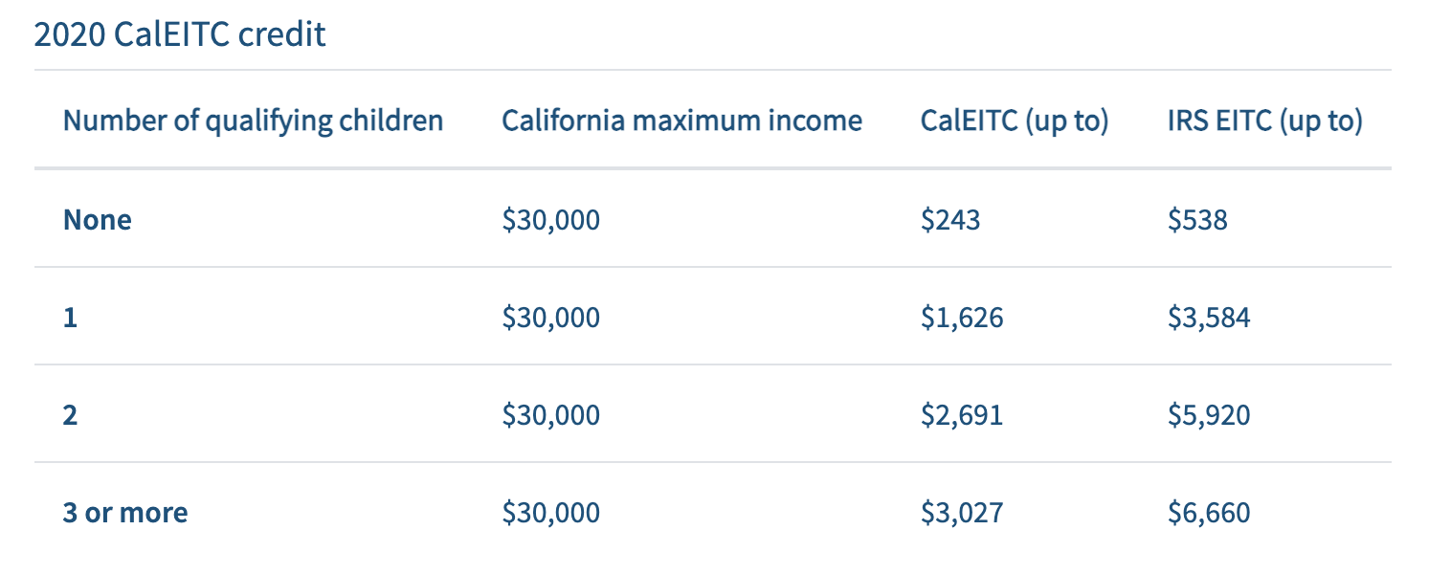Source: State of California Franchise Tax Board

**Table 2: 2020 EITC credit in New York City**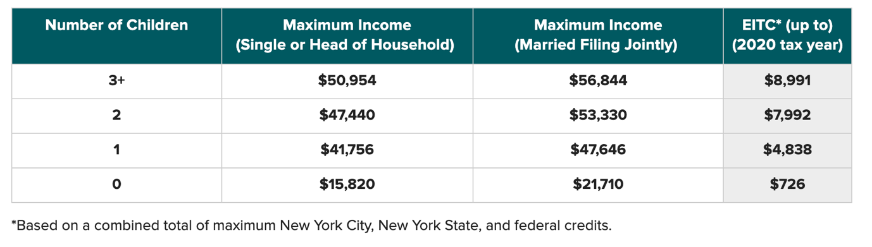

Source: The Office Website of New York State